Capstone Project on Data Warehouse Design and ETL Implementation Using Informatica:
Given dataset: Loan Approval Dataset

Columns in the data set :
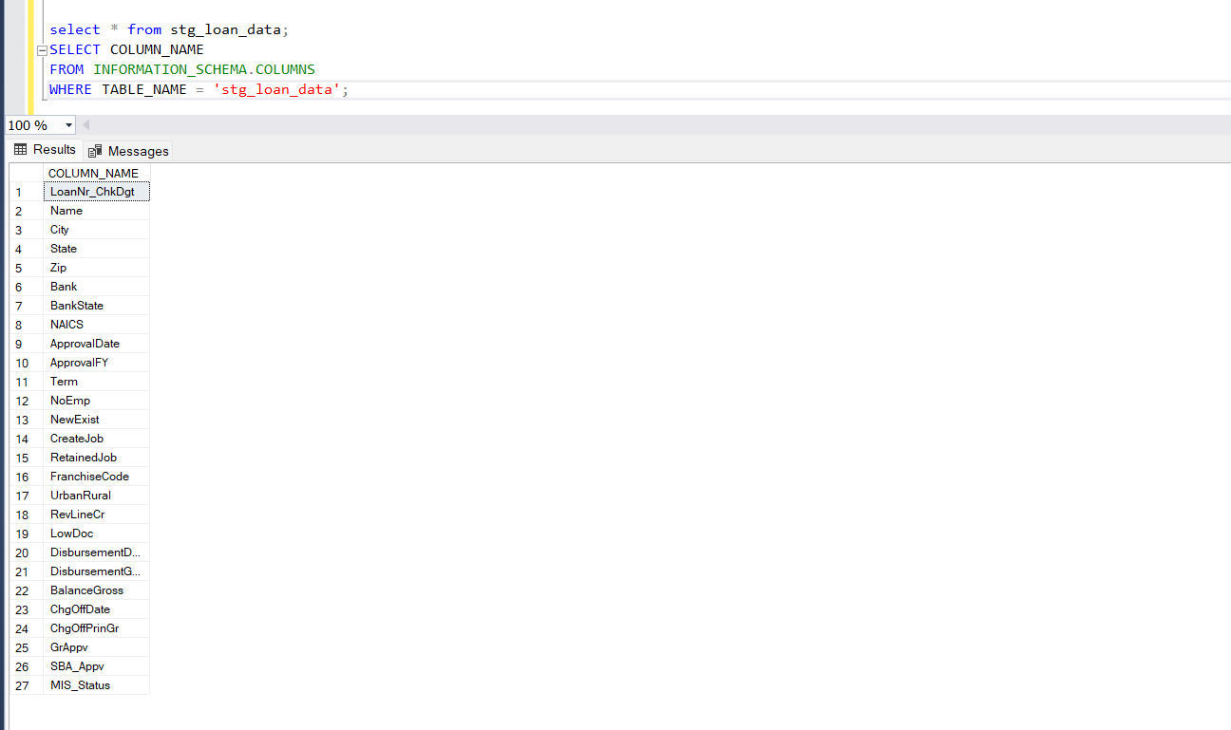

LOAD TYPES:
- Dim_borrower_data -->SCD2
- Dim_bank_data ----> SCD2
- Dim_loandetails_data -->SCD1
- Dim_geography_data -->Regular mapping

FACT TABLE:
Loan_Fact --> SCD1

2. ETL Implementation:
○ Define a data loading strategy for both dimensions and fact tables.
○ Create and populate staging tables using Informatica.
○ Develop mappings and workflows to load dimension and fact tables in adherence to the defined strategy.

SRC to staging table:
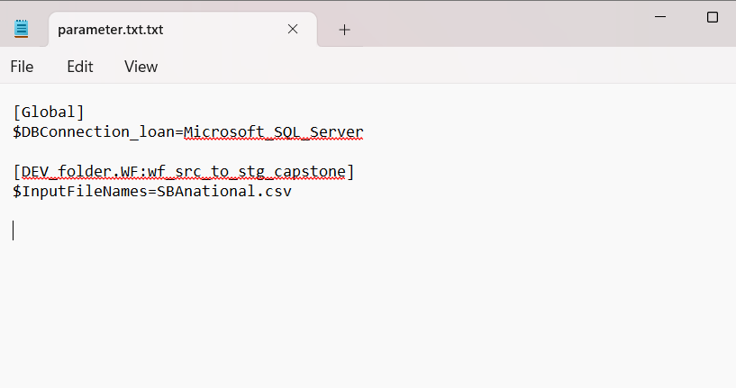
Mapping:
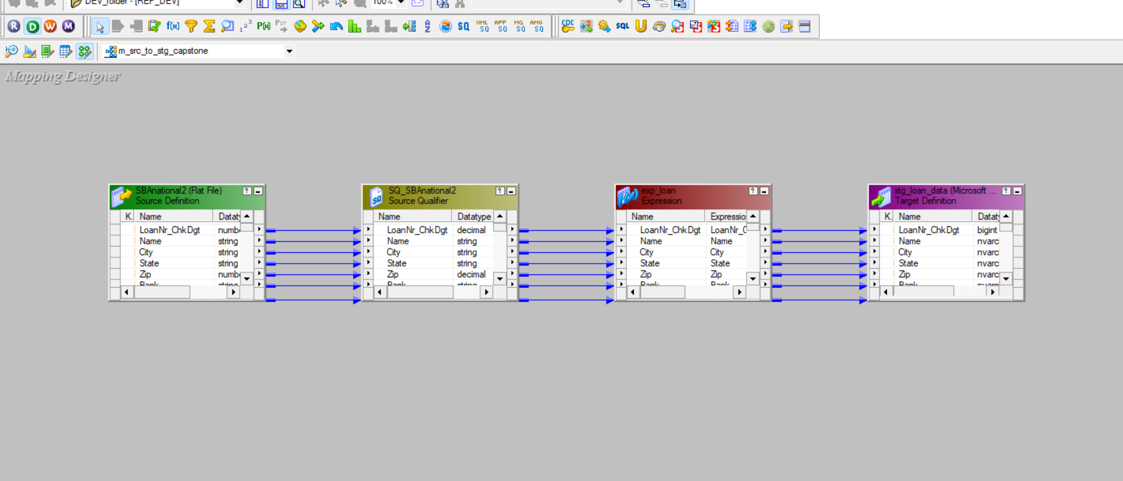
Workflow:
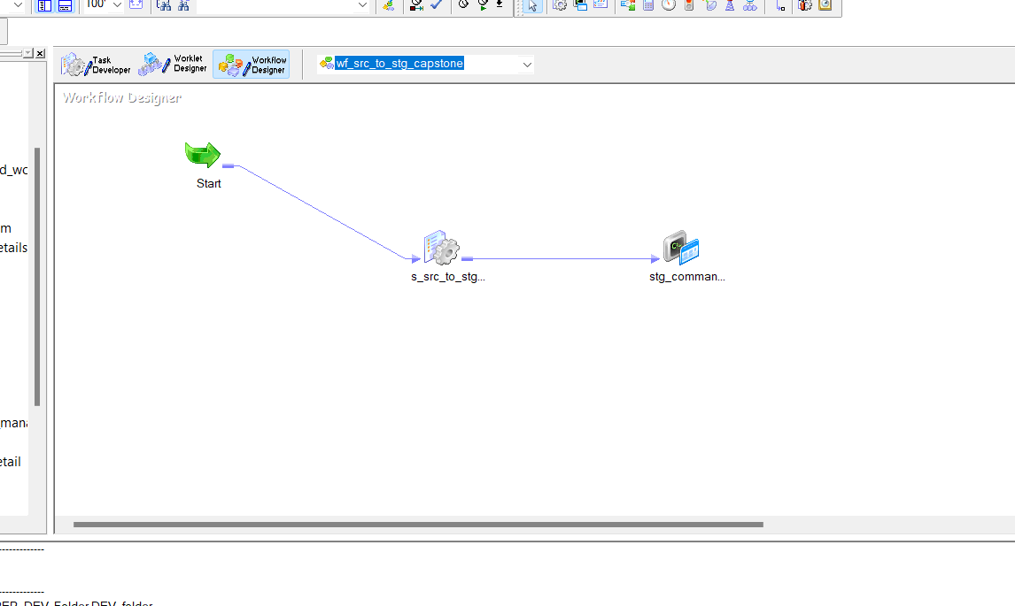

Dim_bank_data :
MAPPING:
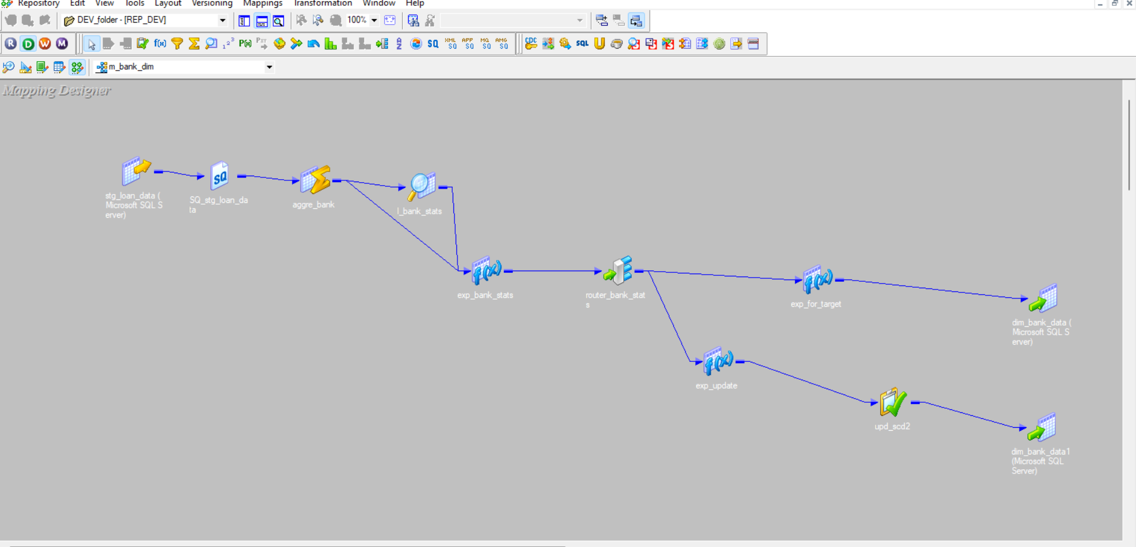
WORKFLOW:
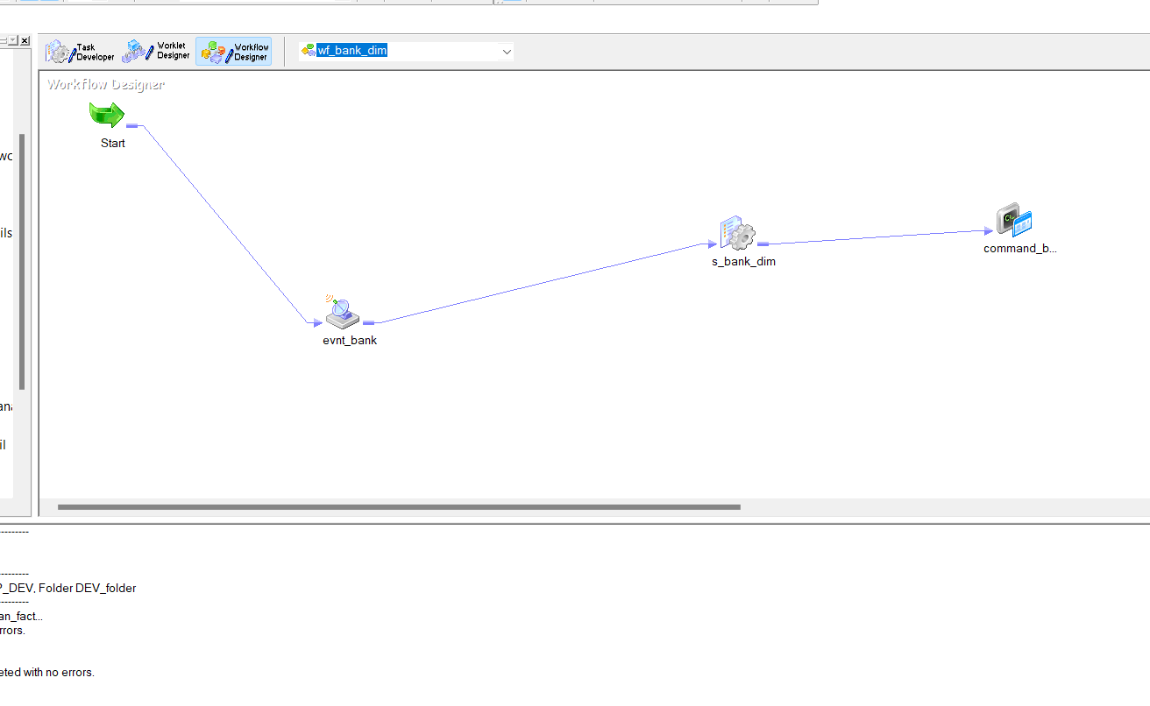

Dim_borrower_data :
MAPPING:
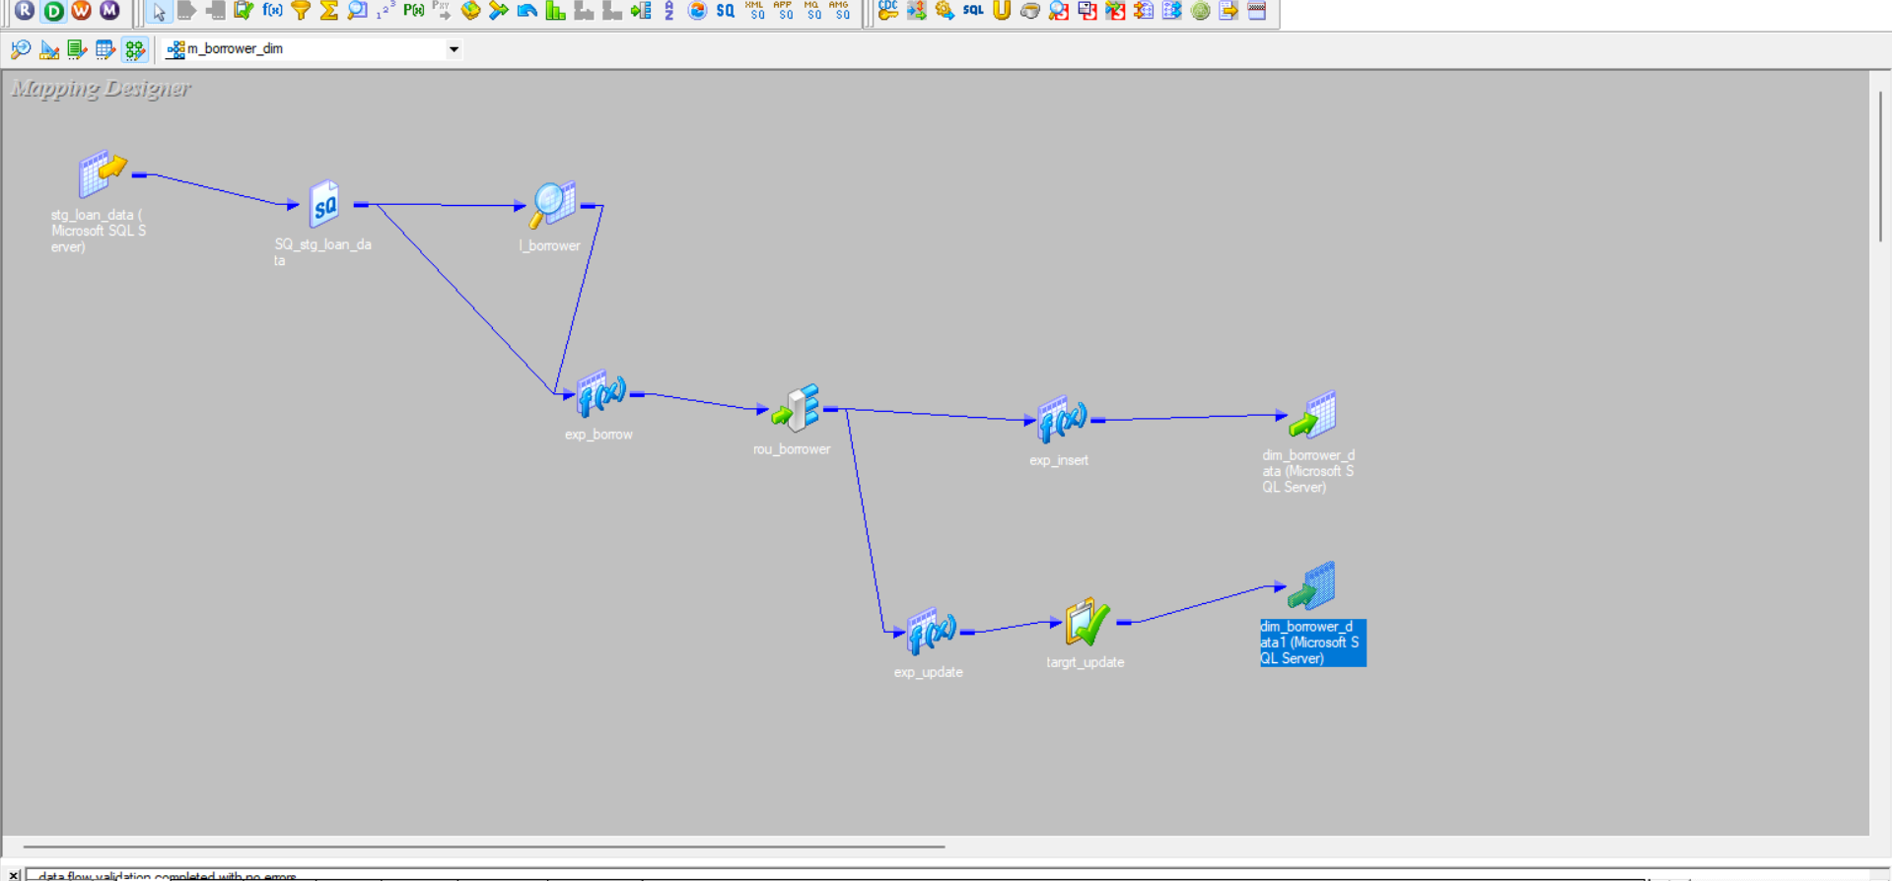
WORKFLOW:
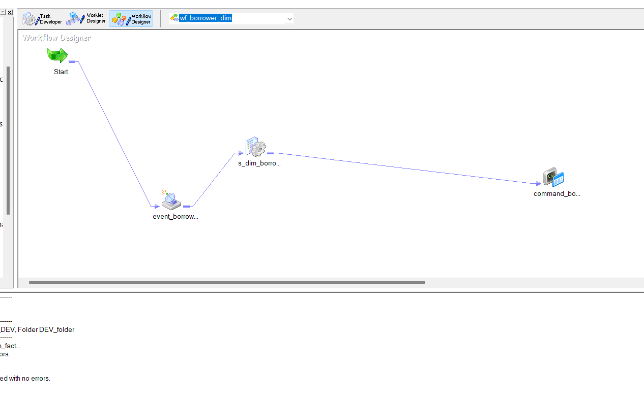

Dim_loandetails_data
MAPPING:
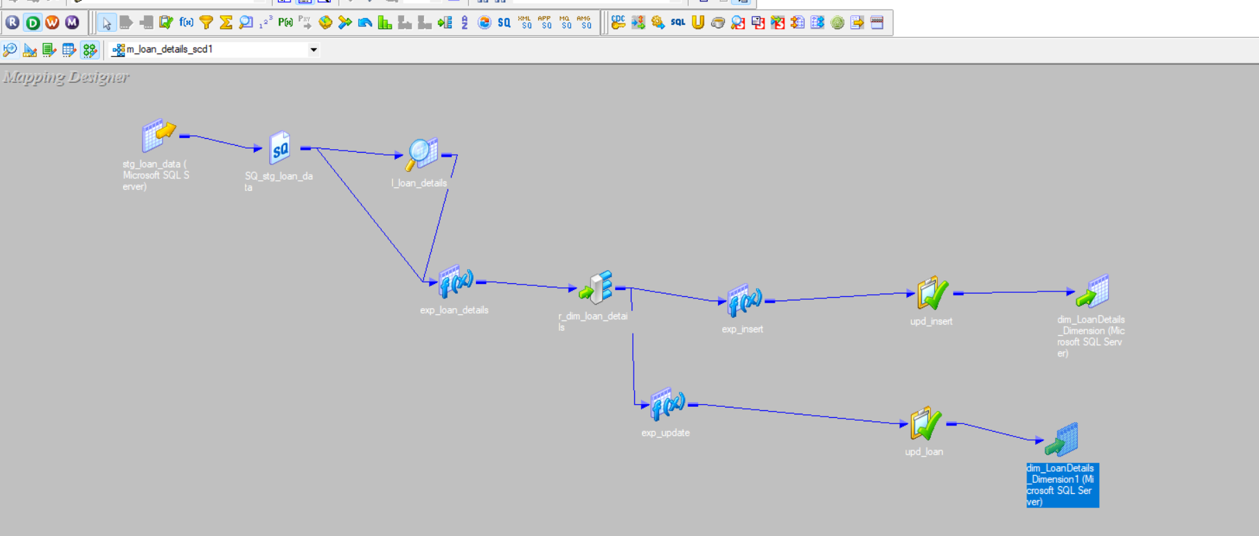
WORKFLOW:

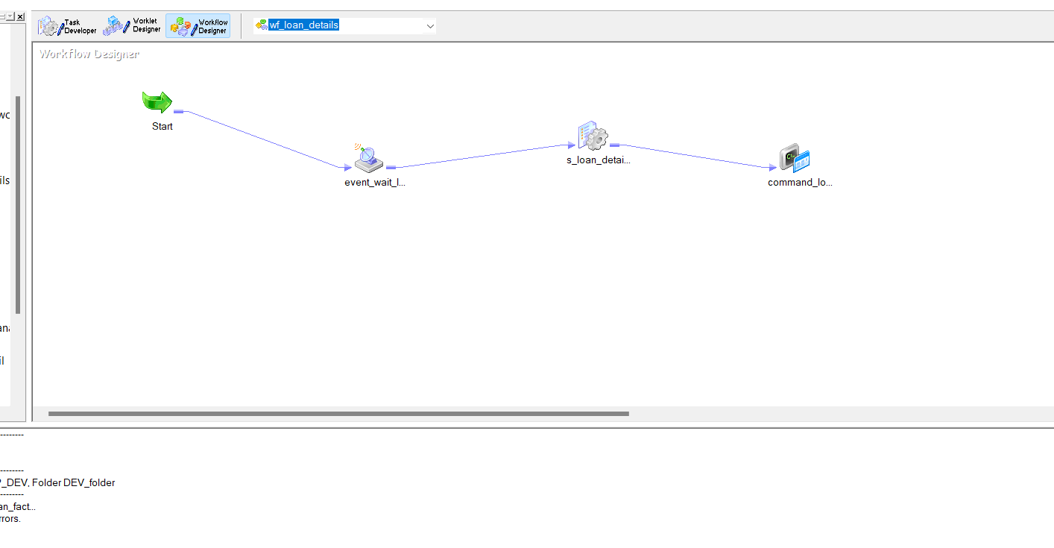
Dim_geography_data :
MAPPING:

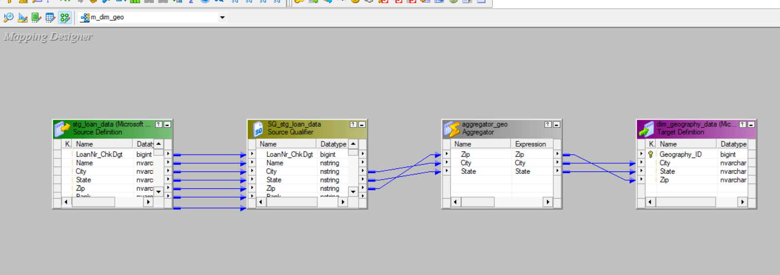
WORKFLOW:
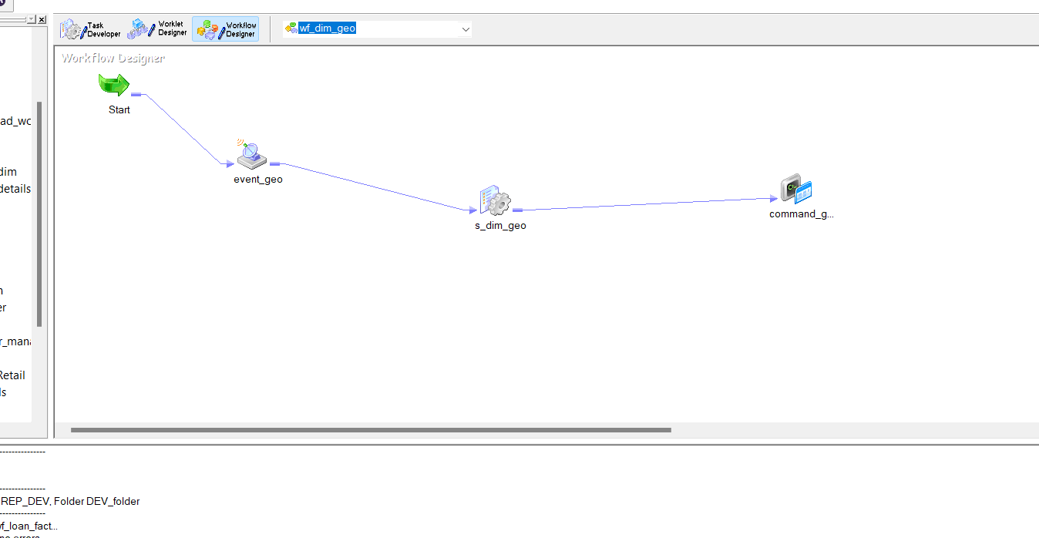

LOAN_FACT:
MAPPING:
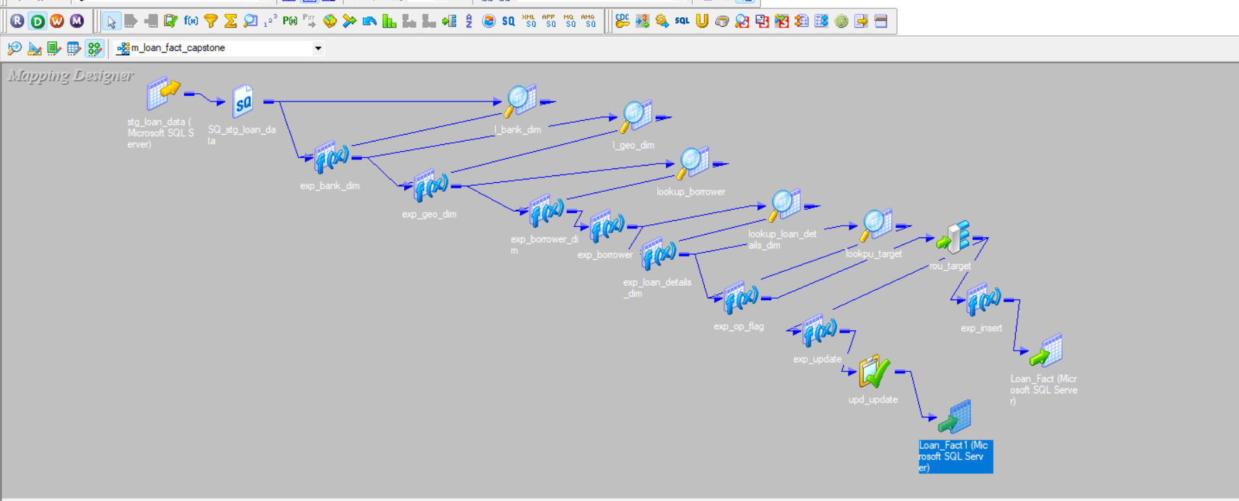
WORKFLOW:

